Solution for Problem 6
Sample table are as follows:
First 5 Dimension Tables:
- Franchise table
Simplest as same as ERD Table of Franchise.
Franchise
FranchId | FranchRegion | FranchPostalCode | FranchModelType
F1 | Northwest | 98011 | Full
F2 | Mountain | 80111 | Medium
F3 | Central | 45236 | Limited

- Member

First 3 rows are taken directly from the Member Table given in the ERD Diagram.
Next 1 Row (George) is the Guest Customer , he is given Type G.
Next 3 Rows (Corporate Customers) are given Type. C
MemEmail is NULL for some can be collected.
There is MemDate given for Guest or Corporate Customers.

Member
MemId | MemName | MemDate | MemEmail | MemType | MemZip
1111 | Joe | 1-Feb-2009 | joe@serv1.com | M1 | 98011
2222 | Mary | 1-Jan-2010 | mary@serv2.com | M2 | 80112
3333 | Sue | 3-Mar-2011 | sue@serv3.com | M3 | 45327
4444 | George |  | george@serv4.com | G | 45236
5555 | Frist Data |  |  | C | 80113
6666 | DU Tennis |  |  | C | 89256
7777 | Creek High School |  |  | C | 83698

3.Product
ProdId is of three types:
PSC for Services
PS for Special Events
M for Membership
Product
ProdId | ProdName | ProdType
M1 | Gold | Membership
M2 | Platinum | Membership
M3 | value | Membership
PSC1 | Ball machine | Service
PSC2 | Private lesson | Service
PSC3 | Adult class | Service
PSC4 | Child class | Service
PS1 | Adult social | Special Event
PS2 | Pioneer social | Special Event
PS3 | Team practice | Special Event
- Merchandise
MerchId starts from MC.
Merchandise
MerchId | MerchName | MerchType
MC1 | Wilson balls | Balls
MC2 | Wilson racket | Racket
MC3 | Adidas shoes | Shoes
MC4 | Racket stringing | Racket

- Calendar
As mentioned in the question:
Your sample rows should include all revenue events in the range February 10, 2013 to February 21, 2013.
CallId starts from letter C.

Calendar
CalId | CalDay | CalMonth | CalYear
C1 | 10 | 2 | 2013
C2 | 11 | 2 | 2013
C3 | 12 | 2 | 2013
C4 | 13 | 2 | 2013
C5 | 14 | 2 | 2013
C6 | 15 | 2 | 2013
C7 | 16 | 2 | 2013
C8 | 17 | 2 | 2013
C9 | 18 | 2 | 2013
C10 | 19 | 2 | 2013
C11 | 20 | 2 | 2013
C12 | 21 | 2 | 2013

Fact Table
- SalesRecord
Analyzing these records given in the source ERD:
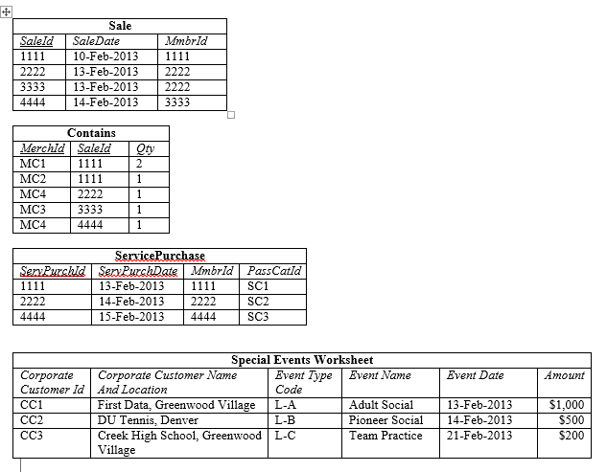
Five Entries from Contains Table,
Next Three from ServicePurchaseTable,
NextThree from SpecialEvents Table
Last three are Membership.
There will be Null values here.
Franchise Id’s are randomly written.
RecordNo | isMerchandise | isService | MerchId | MemId | CallId | ProdId | FranchId | SalesQty | SalesUnitPrice($) | TotalAmt($)
1 | Yes | No | MC1 | 1111 | C1 | NULL | F1 | 2 | 3 | 6
2 | Yes | No | MC2 | 1111 | C1 | NULL | F1 | 1 | 200 | 200
3 | Yes | No | MC4 | 2222 | C3 | NULL | F2 | 1 | 40 | 40
4 | Yes | No | MC3 | 3333 | C3 | NULL | F3 | 1 | 100 | 100
5 | Yes | No | MC4 | 4444 | C4 | NULL | F1 | 1 | 40 | 40
6 | No | Yes | NULL | 1111 | C3 | PSC1 | F2 | 1 | 15 | 15
7 | No | Yes | NULL | 2222 | C4 | PSC2 | F3 | 1 | 75 | 75
8 | No | Yes | NULL | 4444 | C5 | PSC3 | F1 | 1 | 150 | 150
9 | No | Yes | NULL | 5555 | C3 | PS1 | F2 | 1 | 1000 | 1000
10 | No | Yes | NULL | 6666 | C4 | PS2 | F3 | 1 | 500 | 500
11 | No | Yes | NULL | 7777 | C12 | PS3 | F2 | 1 | 200 | 200
12 | No | Yes | NULL | 1111 | C2 | M2 | F3 | 1 | 800 | 800
13 | No | Yes | NULL | 2222 | C3 | M1 | F2 | 1 | 1000 | 1000
14 | No | Yes | NULL | 3333 | C4 | M3 | F1 | 1 | 300 | 300

